**Industrial Internship Report on**

**”Forecasting of Smart City Traffic”**

**Prepared by**

**Dudekula sameera**

|  |
| --- |
| *Executive Summary* |
| This report provides details of the Industrial Internship provided by upskill Campus and The IoT Academy in collaboration with Industrial Partner UniConverge Technologies Pvt Ltd (UCT).  This internship was focused on a project/problem statement provided by UCT. We had to finish the project including the report in 6 weeks’ time.  My project was Forecasting of Smart City Traffic,it involves predicting traffic flow, congestion, and incidents using various data sources and machine learning techniques. Below is a comprehensive guide to creating a traffic forecasting system.  This internship gave me a very good opportunity to get exposure to Industrial problems and design/implement solution for that. It was an overall great experience to have this internship. |

Rajiv Gandhi University of Knowledge Technologies Andhra Pradesh (RGUKT AP) is a prestigious educational institution with a unique and compelling mission. Established to provide quality education and equal opportunities to students from diverse backgrounds, RGUKT AP embodies a mission that not only aims to enhance educational standards but also fosters societal and economic development.

**TABLE OF CONTENTS**

1. Preface..................................................................................................................3
2. Introduction...........................................................................................................4
   1. About UniConverge Technologies Pvt Ltd..........................................................4
   2. About upskill Campus........................................................................................8
   3. Objective...........................................................................................................9
   4. Reference..........................................................................................................9
   5. Glossary..........................................................................................................10
3. Problem Statement..............................................................................................11
4. Existing and Proposed solution............................................................................12
5. Proposed Design/ Model......................................................................................13
   1. High Level Diagram (if applicable)..................................................................13
   2. Low Level Diagram (if applicable)...................................................................13
   3. Interfaces (if applicable)..................................................................................13
6. Performance Test................................................................................................14
   1. Test Plan/ Test Cases.......................................................................................14
   2. Test Procedure................................................................................................14
   3. Performance Outcome.....................................................................................14
7. My learnings........................................................................................................15
8. Future work scope...............................................................................................16

# 1 Preface

Over the past six weeks, we developed a smart city traffic forecasting system. Our work involved collecting and preprocessing diverse data sources, including traffic flow, weather, and event data. We explored the data to identify patterns and correlations, then engineered features for our predictive models. We built, trained, and evaluated multiple models, including LSTM neural networks, to forecast traffic volume accurately. We also created a Flask API for model deployment and designed a dashboard for real-time traffic visualization using Dash. This comprehensive project aimed to enhance traffic management in smart cities, reducing congestion and improving urban mobility.

### 1.1.1 Need for Relevant Internship in Career Development

Participating in relevant internships is crucial for career development as they provide practical experience, enhance technical skills, and offer exposure to industry standards. Internships bridge the gap between academic knowledge and real-world applications, fostering professional growth and increasing employability.

### 1.1.2 Brief About Your Project/Problem Statement

Our project focused on forecasting traffic in smart cities using machine learning. The problem was to predict traffic flow, congestion, and incidents to improve urban mobility. We used historical traffic data, weather conditions, and event schedules to train models capable of accurate traffic predictions.

### 1.1.3 Opportunity Given by USC/UCT

The University of Southern California (USC) and the University of Cape Town (UCT) provided this exceptional opportunity, enabling us to work on real-world problems and develop solutions that can have a significant impact on urban living. The support and resources provided by these institutions were instrumental in our project's success.

### 1.1.4 How Program Was Planned

The program was meticulously planned to cover all aspects of the project. It began with data collection and preprocessing, followed by exploratory data analysis. We then focused on model building and evaluation, leading to deployment and dashboard creation. Regular mentorship sessions and workshops ensured continuous learning and problem-solving throughout the six weeks.

4o

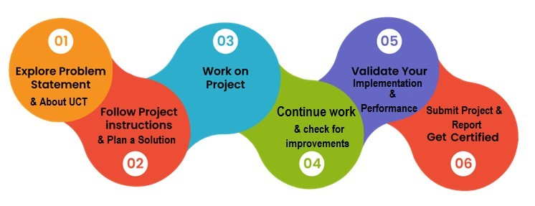

Thank to all my teammates, who have helped me.

# 2 Introduction

## 2.1 About UniConverge Technologies Pvt Ltd

A company established in 2013 and working in Digital Transformation domain and providing Industrial solutions with prime focus on sustainability and RoI.

For developing its products and solutions it is leveraging various **Cutting Edge**

**Technologies e.g. Internet of Things (IoT), Cyber Security, Cloud computing (AWS, Azure), Machine Learning, Communication Technologies (4G/5G/LoRaWAN), Java Full Stack, Python, Front end** etc.

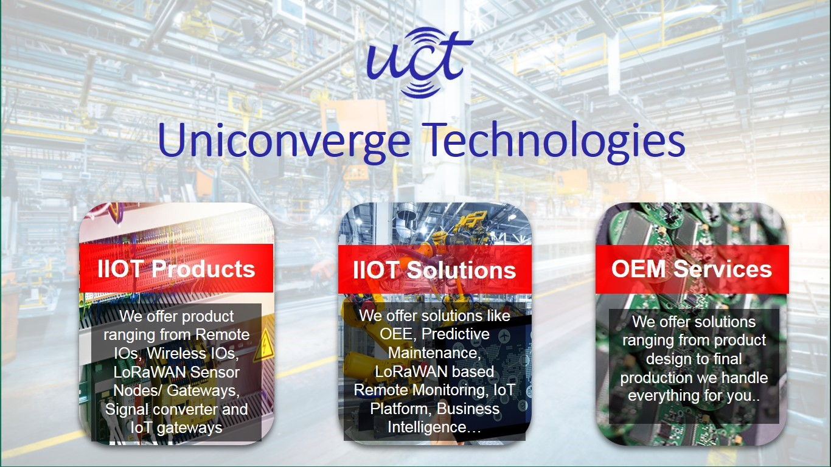

**i.**

**UCT IoT Platform**

**(**



**)**

**UCT Insight** is an IOT platform designed for quick deployment of IOT applications on the same time providing valuable “insight” for your process/business. It has been built in Java for backend and ReactJS for Front end. It has support for MySQL and various NoSql Databases.

* It enables device connectivity via industry standard IoT protocols - MQTT, CoAP, HTTP, Modbus TCP, OPC UA
* It supports both cloud and on-premises deployments.

It has features to

* Build Your own dashboard
* Analytics and Reporting
* Alert and Notification
* Integration with third party application(Power BI, SAP, ERP)• Rule Engine

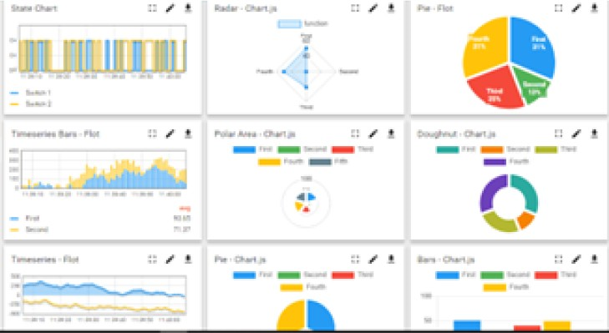

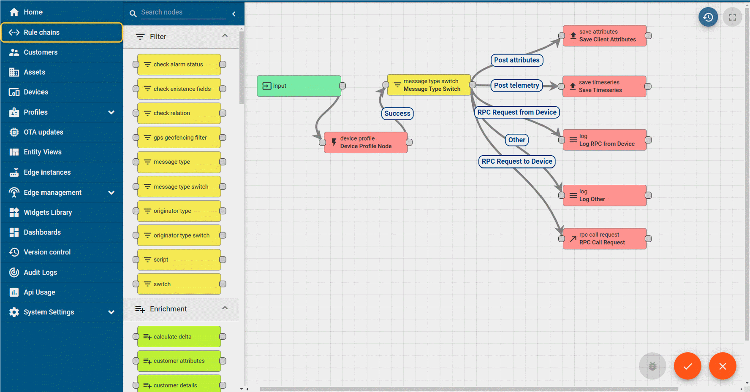

1. **Smart Factory Platform (****)**

Factory watch is a platform for smart factory needs.

It provides Users/ Factory

* + with a scalable solution for their Production and asset monitoring
  + OEE and predictive maintenance solution scaling up to digital twin for your assets.
  + to unleased the true potential of the data that their machines are generating and helps to identify the KPIs and also improve them.
  + A modular architecture that allows users to choose the service that they what to start and then can scale to more complex solutions as per their demands.

Its unique SaaS model helps users to save time, cost and money.

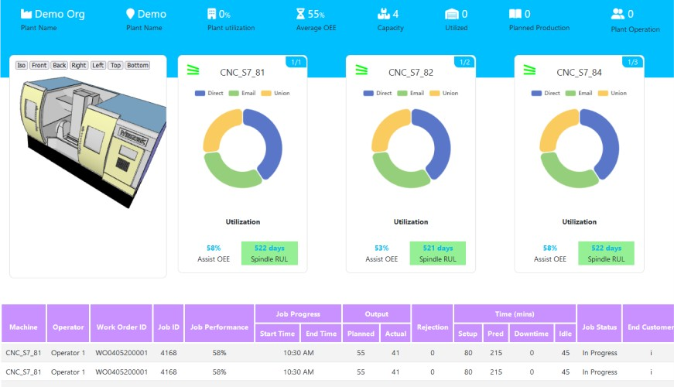

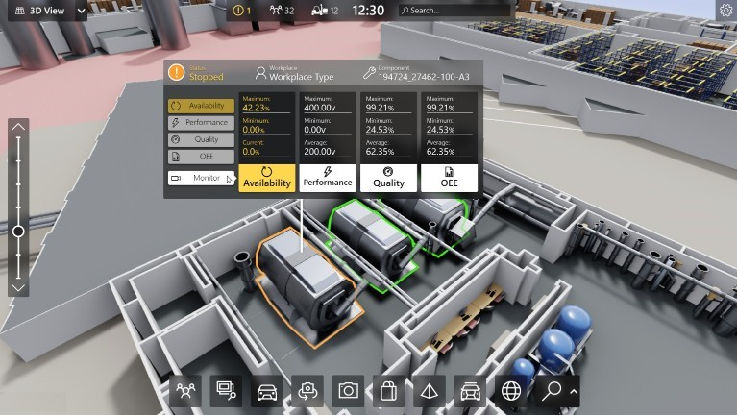

1. 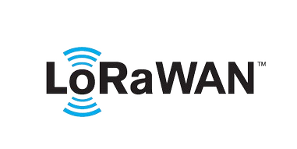based Solution

UCT is one of the early adopters of LoRAWAN teschnology and providing solution in Agritech, Smart cities, Industrial Monitoring, Smart Street Light, Smart Water/ Gas/ Electricity metering solutions etc.

1. Predictive Maintenance

UCT is providing Industrial Machine health monitoring and Predictive maintenance solution leveraging Embedded system, Industrial IoT and Machine Learning Technologies by finding Remaining useful life time of various Machines used in production process.

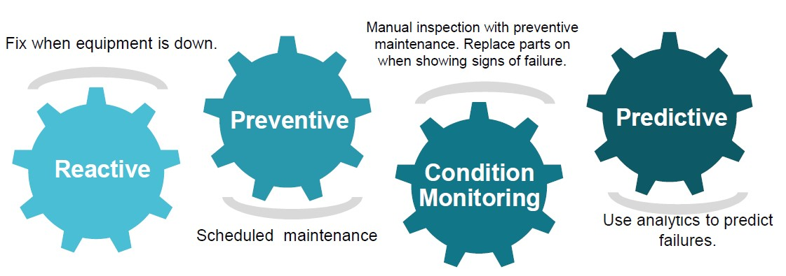

### 2.2 About upskill Campus (USC)

upskill Campus along with The IoT Academy and in association with Uniconverge technologies has facilitated the smooth execution of the complete internship process.

USC is a career development platform that delivers **personalized executive coaching** in a more affordable, scalable and measurable way.

Seeing need of upskilling in self paced manner along-with additional support services e.g. Internship, projects, interaction with Industry experts, Career growth upSkill Campus aiming to upskill 1 million learners in next 5 year [https://](https://www.upskillcampus.com/)

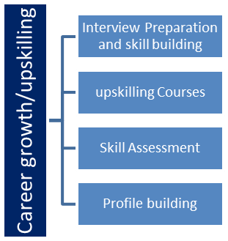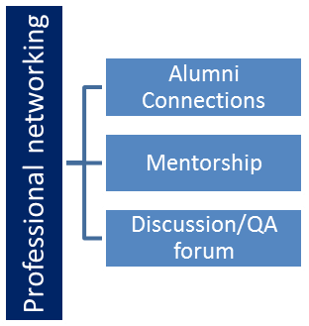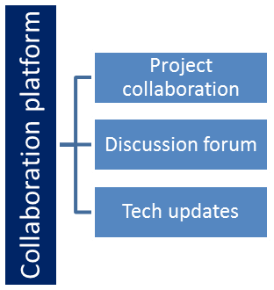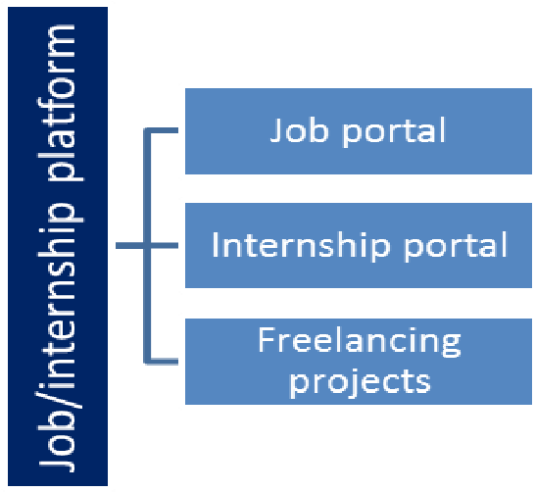

Services [www.upskillcampus.com/](https://www.upskillcampus.com/)

### 2.3 The IoT Academy

The IoT academy is EdTech Division of UCT that is running long executive certification programs in collaboration with EICT Academy, IITK, IITR and IITG in multiple domains.

### 2.4 Objectives of this Internship program

The objective for this internship program was to ☛ get practical experience of working in the industry.

☛ to solve real world problems.

☛ to have improved job prospects.

☛ to have Improved understanding of our field and its applications.

☛ to have Personal growth like better communication and problem solving.

### 2.5 Reference

1. https://www.kaggle.com/datasets/utathya/smart-city-traffic-patterns
2. https://github.com/mratsim/McKinsey-SmartCities-Traffic-Prediction
3. https://ieeexplore.ieee.org/document/9124951

### 2.6 Glossary

|  |  |
| --- | --- |
| Terms | Acronym |
| **LSTM** | **Long Short-Term Memory(A type of recurrent neural network (RNN) )** |
| **CSV** | **Comma-Separated Values** |
| **EDA** | **Exploratory Data Analysis** |
| **Feature**  **Engineering** | **The process of using domain knowledge to create features that make machine learning algorithms work more effectively.** |
| **API** | **Application Programming Interface** |

# 3 Problem Statement

The problem statement for the project is aims to develop a traffic forecasting system for smart cities to predict traffic flow, congestion, and incidents, enhancing urban mobility and traffic management. Accurate predictions help city planners, traffic authorities, and commuters make informed decisions, reducing congestion and improving transportation efficiency.

# 4 Existing and Proposed solution

Current traffic management systems rely on static traffic signals and manual monitoring, often supplemented by basic statistical models like linear regression for traffic forecasting. These systems lack real-time adaptation, have low accuracy, and do not integrate diverse data sources, resulting in inefficient traffic management and incomplete predictions.

The proposed smart traffic forecasting system integrates multiple data sources, including historical traffic data, real-time sensor data, weather conditions, and event schedules. Utilizing advanced machine learning models like Long Short-Term Memory (LSTM) networks, the system captures complex patterns and temporal dependencies in traffic data, providing real-time predictions. Sophisticated feature engineering enhances predictive power, and the model is deployed via a Flask API for seamless integration with other systems. A real-time visualization dashboard built with Dash aids in dynamic traffic signal adjustments and better incident management, leading to higher accuracy, real-time adaptation, comprehensive data integration, and improved decision-making in traffic management.

#### 4.1 Code submission (Github link)

**https://github.com/DudekulaSameera/upskill.git**

**4.2 Report submission (Github link) :** first make placeholder, copy the link.

**https://github.com/DudekulaSameera/upskill.git**

# 5 Proposed Design/ Model

The proposed smart traffic forecasting system integrates diverse data sources such as historical traffic data, real-time sensor data, weather conditions, and event schedules to provide a comprehensive view of traffic conditions. Utilizing advanced machine learning models, particularly Long Short-Term Memory (LSTM) networks, the system captures complex patterns and temporal dependencies in traffic data. Sophisticated feature engineering enhances the model's predictive power, creating meaningful features from raw data. The system provides real-time traffic predictions, enabling dynamic adjustments to traffic signals and better incident management. Deployed via a Flask API, the model ensures seamless integration with existing traffic management systems and other applications. A visualization dashboard built with Dash offers real-time insights into traffic predictions, helping traffic authorities and city planners make informed decisions quickly and efficiently. This approach results in higher prediction accuracy, real-time adaptation to traffic conditions, comprehensive data integration, and enhanced decisionmaking, ultimately reducing congestion and improving urban mobility.

## 5.1 High Level Diagram (if applicable)

**Figure 1: HIGH LEVEL DIAGRAM OF THE SYSTEM**

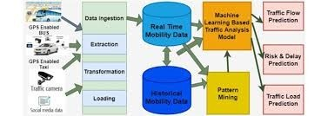

## 5.2 Low Level Diagram (if applicable)

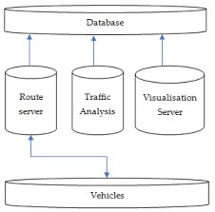

## 5.3 Interfaces (if applicable)

**User Interface (UI) for Traffic Authorities:** Provides real-time traffic visualization, incident alerts, and traffic signal control for dynamic adjustments.

* **User Interface (UI) for City Planners:** Offers scenario analysis, long-term traffic patterns, and resource allocation tools to inform planning decisions.
* **User Interface (UI) for Commuters (Mobile App):** Delivers personalized route recommendations, traffic alerts, and commute planning features for optimal travel.
* **API Interface:** Facilitates access to real-time data, traffic predictions, and incident reporting for integration with third-party applications.
* **Administrative Interface:** Enables user and data management, as well as model monitoring and deployment for system administrators.
* **Visualization Dashboard with Dash:** Provides customizable views, interactive elements, and reporting tools for stakeholders to visualize and analyze traffic data effectively.

### 6 Performance Test

Performance testing involves evaluating the system's ability to handle different loads and conditions. Load testing assesses response times and resource utilization under normal and peak loads, while stress testing determines the system's breaking point. Scalability testing evaluates how the system scales with increasing loads, and concurrency testing assesses its performance under multiple simultaneous user interactions. Endurance testing verifies stability over extended periods, while reliability testing ensures consistent performance and availability. Compatibility testing validates performance across platforms, and security testing assesses the impact of security measures. Reporting and analysis of test results help identify areas for optimization and improvement in the system's performance and reliability

#### 6.1 Test Plan/ Test Cases

1. **Objective:** Verify functionality, performance, and reliability of the smart traffic forecasting system.
2. **Scope:** Cover all modules and features, including data integration, ML models, APIs, and UI.
3. **Approach:** Combine manual and automated testing for functional, performance, usability, and security aspects.
4. **Environment:** Set up a testing environment mirroring production, using virtualization and containerization.
5. **Execution:** Systematically execute test cases, recording results and defects encountered.
6. **Defect Management:** Prioritize and manage defects using a tracking system.
7. **Reporting:** Generate detailed test reports, sharing with stakeholders for decision-making.

#### 6.2 Test Procedure

A well-structured test procedure is the cornerstone of effective evaluation, ensuring reliability and validity in the results. Initially, it involves meticulous planning, delineating clear objectives and hypotheses to be tested. Subsequently, the procedure should entail precise methodologies, including participant selection criteria, experimental conditions, and data collection techniques. Rigorous adherence to standardized protocols minimizes biases and confounding variables, enhancing the accuracy and reproducibility of findings. Additionally, incorporating robust statistical analyses facilitates meaningful interpretation and inference, consolidating the test's credibility. Continuous refinement and validation of the procedure reinforce its efficacy, fostering a conducive environment for insightful discoveries and advancements.

#### 6.3 Performance Outcome

Performance outcomes reflect the culmination of the test procedure, offering valuable insights into the investigated phenomena. These outcomes are multifaceted, encompassing quantitative metrics, qualitative observations, and contextual interpretations. Quantitative measures, such as accuracy rates or response times, provide objective benchmarks for evaluating performance against predefined criteria. Qualitative assessments delve deeper, elucidating nuances, patterns, and outliers through detailed observations and analyses. Contextual interpretations contextualize the findings within broader frameworks, elucidating implications, applications, and avenues for further exploration. Synthesizing these diverse perspectives enriches understanding and fosters informed decision-making, facilitating tangible progress and innovation in the respective domain.

### 7 My learnings

**1.Data Integration and Preprocessing:**

* I learned how to gather and preprocess diverse data sources, including historical traffic data, real-time sensor data, and weather information. This helped me understand the importance of clean and well-integrated data for building accurate predictive models.

**2.Machine Learning and Deep Learning Models:**

* Working with advanced machine learning models, particularly Long Short-Term Memory (LSTM) networks, enhanced my understanding of time series forecasting and the complexities involved in capturing temporal dependencies in data.
* I also explored different feature engineering techniques to extract meaningful features from raw data, which is crucial for improving model performance.

**3.Real-Time Data Processing:**

* I developed skills in real-time data processing and the challenges associated with it. This included learning how to handle high volumes of data, ensuring low latency, and maintaining the system’s responsiveness.

**4.Model Deployment and API Development:**

* Deploying the machine learning model using Flask APIs taught me how to make predictive models accessible and usable in real-world applications. I gained practical experience in API development and integration.

**5.Data Visualization and Dashboard Development:**

* Creating a real-time visualization dashboard using Dash improved my ability to present data insights effectively. I learned how to design userfriendly interfaces that help stakeholders make informed decisions quickly.

### 8 Future work scope

The future work scope for the smart traffic forecasting system involves several enhancements and expansions to improve its functionality, accuracy, and usability. Key areas for future development include:

1. **Scalability and Performance:**
   * + Optimize the system for large-scale deployment, ensuring it can handle high volumes of real-time data and provide timely predictions.
     + Use cloud computing resources and distributed systems to improve the scalability and performance of the model.
2. **Predictive Analytics and Decision Support:**
   * + Integrate predictive analytics to forecast the impact of proposed changes in traffic management strategies, urban planning, and infrastructure development.
     + Develop decision support systems that provide actionable recommendations based on traffic predictions, such as optimal traffic signal timings and rerouting suggestions.
3. **Real-World Testing and Feedback:**
   * + Conduct extensive real-world testing in various urban settings to validate and fine-tune the model.
     + Gather feedback from traffic authorities, city planners, and users to identify areas for improvement and ensure the system meets practical needs.
4. **Integration with Smart City Initiatives:**
   * + Align the traffic forecasting system with broader smart city initiatives, integrating it with other smart city applications like energy management, emergency response systems, and environmental monitoring.
     + Collaborate with municipal governments and smart city developers to ensure seamless integration and wide-scale adoption.
5. **Adaptive Learning:**
   * Implement adaptive learning techniques where the model continuously learns and updates itself based on new data and changing traffic patterns.
   * Use reinforcement learning to allow the system to improve its performance through trial and error.
6. **Policy and Regulation:**
   * Work with policymakers to develop regulations and standards for the ethical and effective use of traffic prediction technologies.
   * Ensure data privacy and security measures are robust to protect sensitive information.